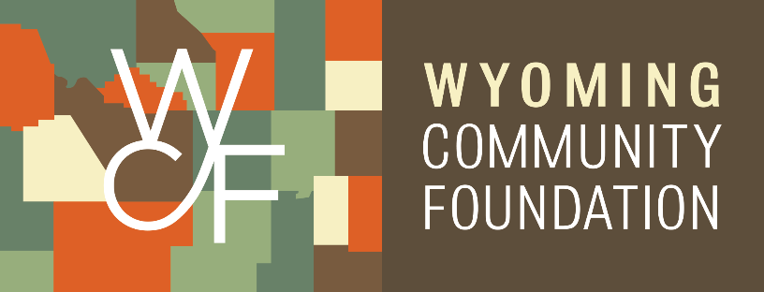

KEEP GLENDO GREAT GRANT RECIEPIENT

FOR IMMEDIATE RELEASE

Date: 8/14/24

Contact: Greg Burke

Gjburke2020@gmail.com | 307-220-6494

**Title: Glendo Downtown will have planters for flowers and seasonal decorations!**

Glendo, WY – The Keep Glendo Great Beautification Committee will soon be able to purchase sturdy decorative planters and add flowers or seasonal decorations due largely to a grant received from the **Wyoming Intertie Community Investment Program** of the Wyoming Community Foundation and in part due to a grant received from the **Black Hills Energy Corporation** Community Giving Program.

Keep Glendo Great is a nonprofit organization serving the greater Glendo area to help the greater Glendo community residents, businesses, and town meet its strategic plan through funding and supporting beautification, tourism, communication, business development, and community enhancement efforts. Keep Glendo Great has operated for less than a year and has achieved many improvements already to beautify the downtown, support school tennis court resurfacing, and bring many new events to town to support our wonderful businesses and broaden events for the community. The funds received will strengthen the work being done in coming months to improve the look of our community. Stay tuned for more actions in coming months.

To learn more about Keep Glendo Great or to donate, visit https://townofglendo.com/ or contact Greg Burke at 307-220-6494 or gjburke2020@gmail.com

- more -

*The Wyoming Community Foundation is a nonprofit organization that works with donors to support the charitable causes they care most about. In 2023, the Wyoming Community Foundation granted over $8 million to charitable causes across the state.*

For information call 307-721-8300 or visit their website at [www.wycf.org](http://www.wycf.org).

# # #